


Title



Trade Hunter – System Analysis

Third Year Of Computer Engineering

Authors:
Julen Gabilondo, Peru Ramos, Unai Laskurain, Andoni Usandizaga And Xabat Maortua
29th of November of 2023
Index
1 Objectives of the project 1
1.1 Objectives 1
1.2 System architecture 1
2 Requirements 4
2.1 Use cases 4
2.2 Entity relationship diagram 8
2.3 Class diagram 10
3 Project organization 11
3.1 Project management 11
3.2 Web engineering II 11
3.3 Operating systems 12
3.4 Professional software development 12
3.5 Artificial intelligence 12
3.6 Development environment 13

Figure index
1-1. Figure: System architecture 2
2-1. Figure: General use cases diagram 4
2-2. Figure: Stock market index prediction use cases 5
2-3. Figure: Data Visualization use cases 6
2-4. Figure: User Management use cases 7
2-5. Figure: Forums use cases 7
2-6. Figure: Stock market index simualtion use cases 8
2-7. Figure: Trade Hunter Entity-Relationship Model 9
2-8. Figure: Trade Hunter Entity-Relationship Diagram 9

Objectives of the project

Objectives
Developing a Robust AI Model for Stock Market Predictions
The primary objective of this project is to craft an AI model capable of making reliable predictions about the stock market. The aim is to achieve a minimum value of coefficient of determination (R2) of approximately 0.6, ensuring that the model provides predictions that are substantially near the real value. Through historical data analysis, machine learning methodologies, and algorithmic adjustments, the focus remains on creating an accurate predictive model that also offers valuable knowledge to understand the complexities of the stock market.
Minimizing Investment Risks through Comprehensive Risk Evaluation
Another main goal is to reduce investment risks by implementing a comprehensive risk evaluation strategy. This involves an in-depth analysis of historical market data, external variables, and the integration of risk assessment tools within the AI framework. By identifying potential risks and their impacts on investment decisions, the aim is to provide investors with a clearer understanding of the potential obstacles and strategies to minimize financial exposure.
Helping Users Understand the Stock Market
Beyond predictions, an essential objective of this project is to empower users with a deeper comprehension of the stock market. Through intuitive interfaces, informative content, and user-friendly tools, the aim is to simplify complex market concepts and trends. Providing educational resources, market analyses, and explanations of prediction outcomes ensures users gain a better understanding of the market landscape and investment dynamics.
Creating forums for users to discuss
An integral objective of this project is to create interactive forums for users. These forums aim to promote a collaborative environment where users can engage in discussions, share insights, and exchange ideas related to the stock market. By providing a platform for open dialogue, users can communicate with each other, seek advice, and learn from diverse perspectives within the investment community. The goal is to encourage active participation, facilitate knowledge sharing, and build a supportive network where users can enhance their understanding of market dynamics through collective learning experiences.
Elaborating a Recommendation System
The objective here is to create a smart recommendation system. This system will analyze users' interests and suggest specific forums related to the stock market that might match their preferences. It aims to provide personalized suggestions to users, guiding them towards forums where they can engage in discussions aligned with their interests in the stock market. The goal is to enhance user experience by offering customized recommendations, facilitating their participation in relevant and engaging discussions within the investment community.

System architecture
To accomplish the objectives defined in the previous section, a system architecture has been developed, as it can be seen in the image below. In this section this architecture and all the components that are part of it will be defined, as well as the interconnection between them.
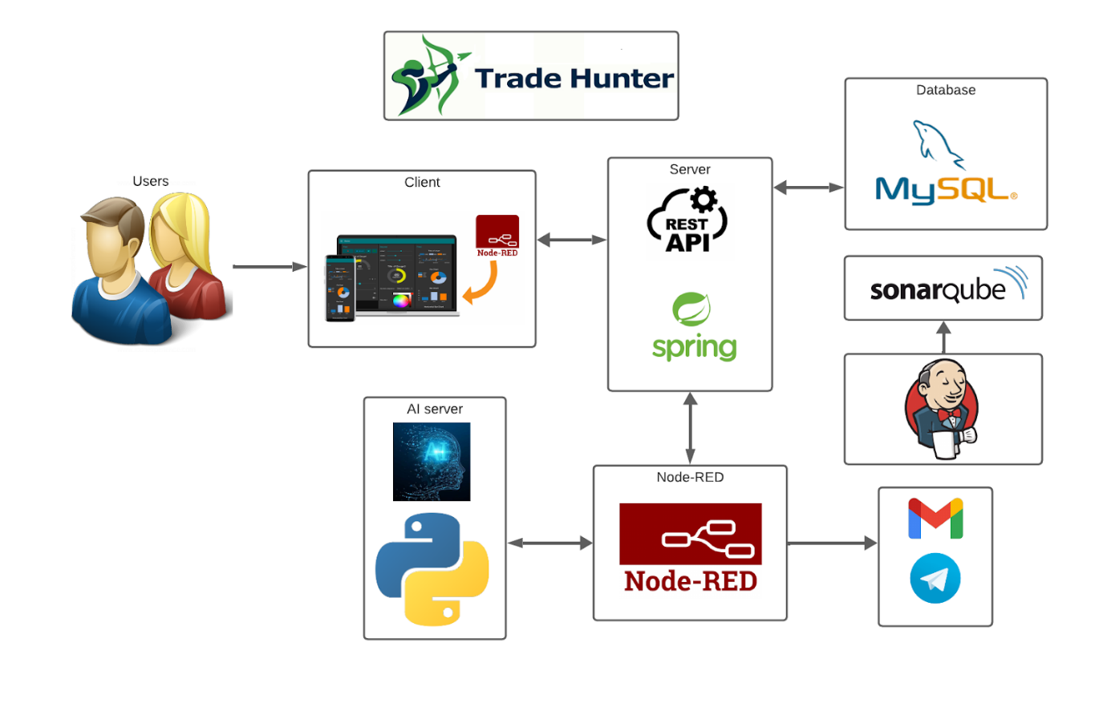
1-1. Figure: System architecture
The Trade Hunter system is composed of several interconnected components that collaborate to provide a comprehensive solution for forecasting stock market trends. Users engage with the system through the Node-RED dashboard, which serves as the front-end or client-side interface. The client communicates user inputs and requests to the server, initiating a dynamic interaction.
The server, developed with Spring, acts as the back-end where the core business logic is implemented. It processes user requests, executes business operations, and communicates with other key components. Communication flows bidirectionally between the client and the server, ensuring seamless user experiences.
The server also interacts with the AI server, developed with Python, to leverage artificial intelligence algorithms for market trend predictions. Data, including historical market data and user preferences, is exchanged between the server and the AI server. The results of the analysis, such as market predictions, are then sent back to the server for further processing and user presentation.
To support data storage needs, the server communicates with the MySQL database. It stores and retrieves relevant information, including user data and market data. This connection to the database ensures persistent and efficient data management within the system.
Continuous code quality inspection is facilitated through SonarQube, an open-source platform. The server undergoes continuous inspection, and Jenkins, an automation server, is employed to automate the SonarQube scanning process. This integration ensures that the system's code quality is monitored throughout the development lifecycle.
The client-side with Node-RED may trigger the bot, responsible for sending messages to Gmail or Telegram, based on certain conditions. The client communicates with the bot using Node-RED to initiate message notifications, enhancing user communication and alert capabilities.
Node-RED plays a pivotal role as an integration hub within the architecture. It connects hardware devices, APIs, and online services, facilitating the flow of data and commands between different components within the system. This integrative approach ensures a holistic and efficient operation of the Trade Hunter system, combining user interaction, business logic, artificial intelligence, data storage, code quality inspection, and external communication through the bot and Node-RED.

Requirements

Use cases
In the project there are the following 3 actors, Freemium user, System administrator and Premium users. Taking into account that the project is divided into 5 sections, the above mentioned actors make some of these sections.
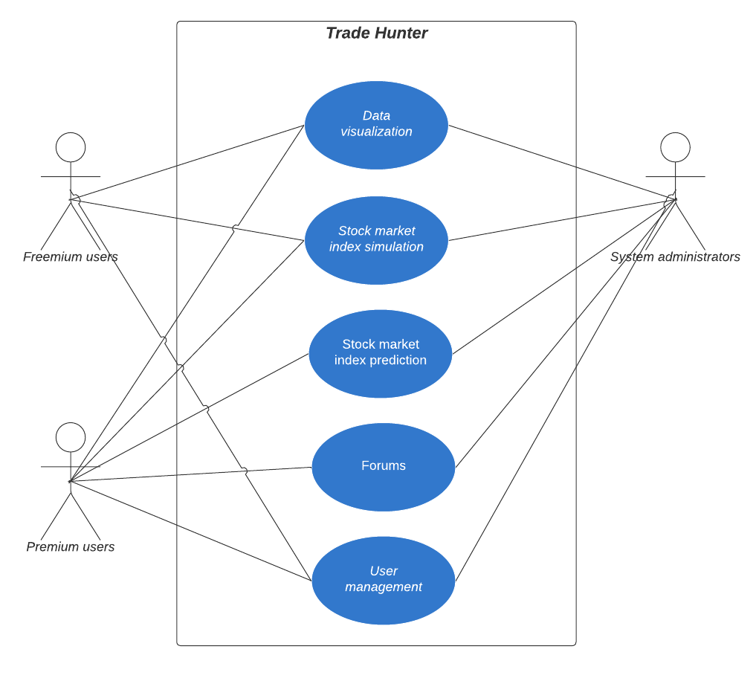
2-1. Figure: General use cases diagram
As it can be seen in the image, first of all, Freemium users can do the following sections: Data Visualization, Stock market index simulation and User management. Secondly, those who are administrators can do all the sections, that is to say, in all the sections they have functionalities. Finally those who are Premium Users as well as administrators have functionalities in each of the sections, thus participating in all of them. From this point it will be explained each one of the sections and what functionality each one of them has.
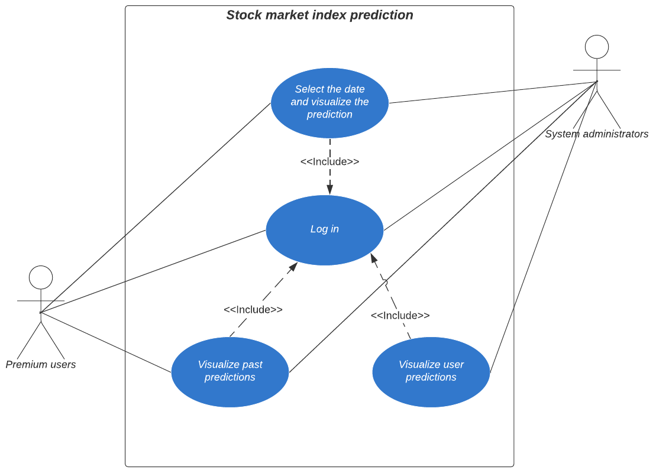
2-2. Figure: Stock market index prediction use cases
Before explaining the functionalities of this section, it is necessary to explain what this section is about. This section is the part of the Web where a user will be able to visualize the following market movements. As mentioned above, in the Stock market index prediction section not all players participate, only Premium users and System administrators participate. This is because only administrators (owners of the program) or Premium users, i.e. users who have paid for the service and therefore obtain this functionality, will be able to visualize the future of the market.
To be able to do any of these functionalities the user must first log in, that is to say, it must register on the web to check the type of user it is, since this defines the functionalities it can do. It should be mentioned that in this section the two actors have the same functionalities, which are the followings: first select the date and the data of what we want to visualize, so that after that they can visualize the predictions that have been made previously or the predictions that will be made in the future.
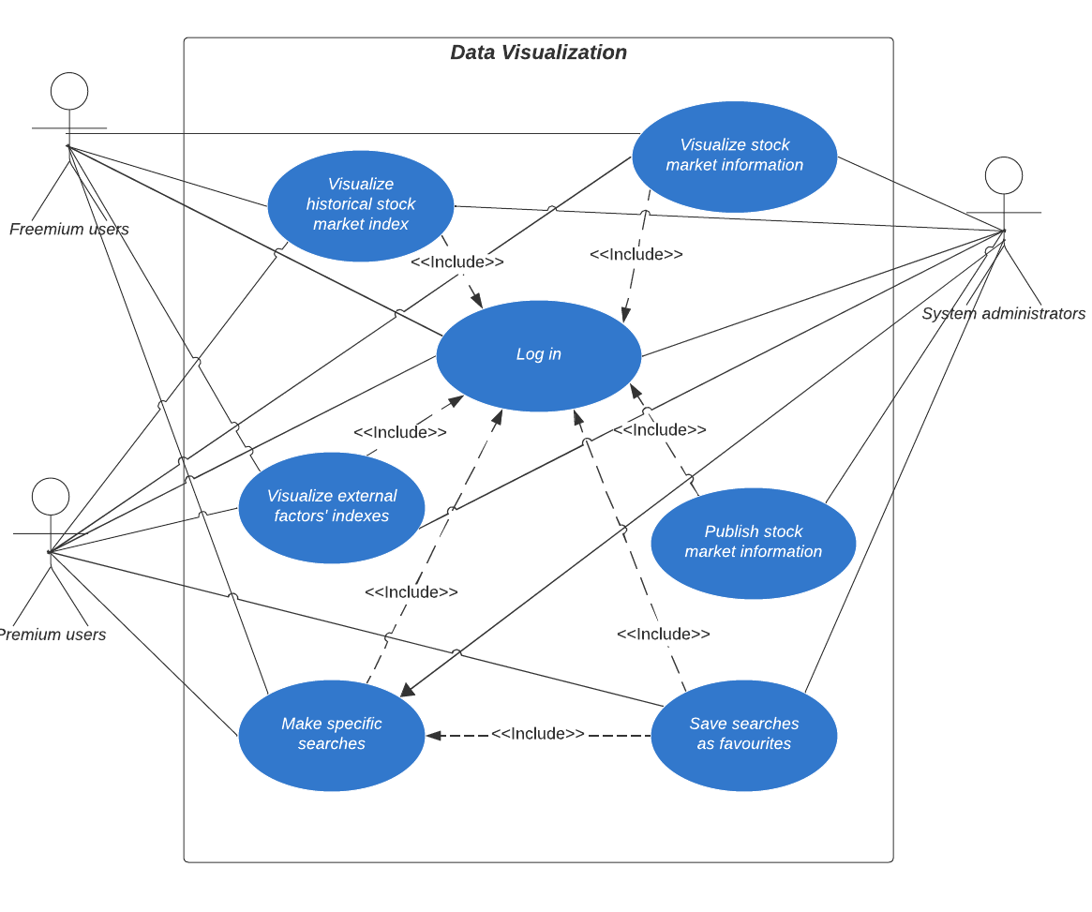
2-3. Figure: Data Visualization use cases
In the Data Visualization section the user tries to visualize all the information, either from the model data, such as external factors, or it can also visualize user data, such as previous searches added to favorites. In this section one of the users that does not have all the functionalities is the Freemium user, who has all the functionalities except publish stock market information and Save searches as favorites. In addition to the Freemium users, the Premium user can not do the functionality of Publish stock market information, since the web page can only be edited by the administrator. As for the functionalities, it should be mentioned that for all of them it must first login before each one of them. In addition, for the functionality of having saved searches in favorites, it must have previously made specific searches and added them to favorites.
In addition to the aforementioned functionalities, there are others such as visualizing external factors of the model or visualizing the historical market value of a specific stock. This functionality is very similar to visualize stock market information, but they are not the same. The first one shows all the information in a graph, the second one shows the same information but in a more educational way, since the objective of this one is to show the market in an easier and more understandable way than the previous one.
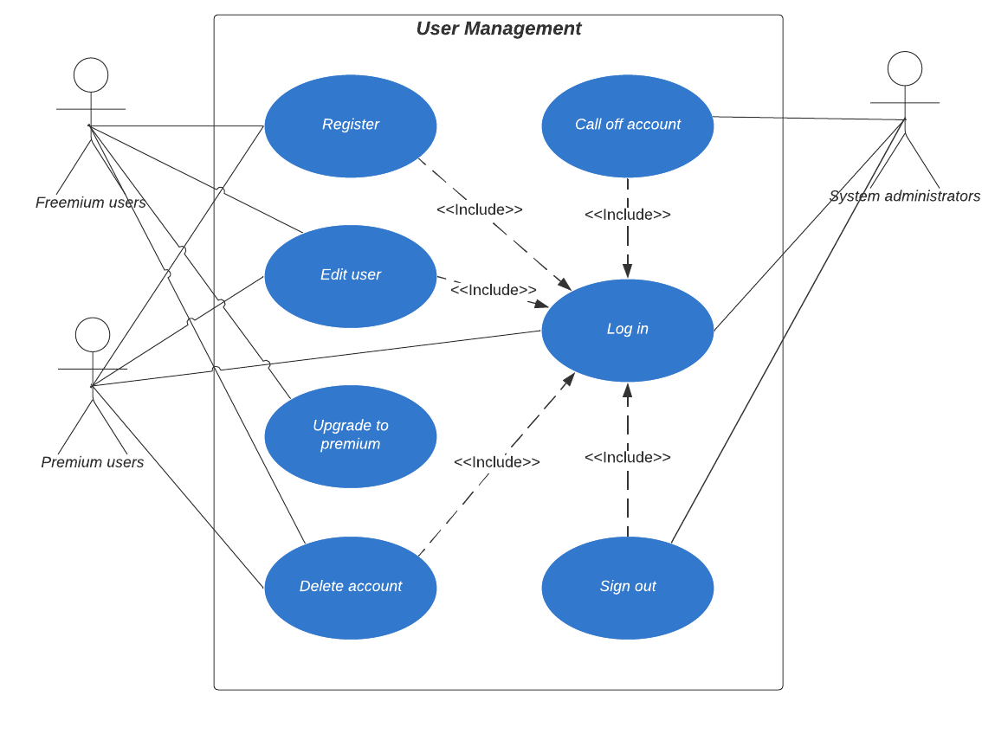
2-4. Figure: User Management use cases
In this section there are the functionalities of each type of user, that is to say the functionalities that have to do with the types of how many. As in the previous sections, in this one it is also compulsory to log in before being able to do any other functionality. The Registration functionality can only be done by premium and freemium players, that is, those who are going to create a new account on the web. Also, they are the only ones who will be able to edit their account or delete it. Finally, only the freemium user can upgrade his account and make it premium, because obviously a premium user will not be able to upgrade it and the administrator is not a type of user who participates in the site but a user to maintain the site. Finally, all accounts can log out. As for the functionality of the administrator can suspend an account for misconduct or a failure in it.
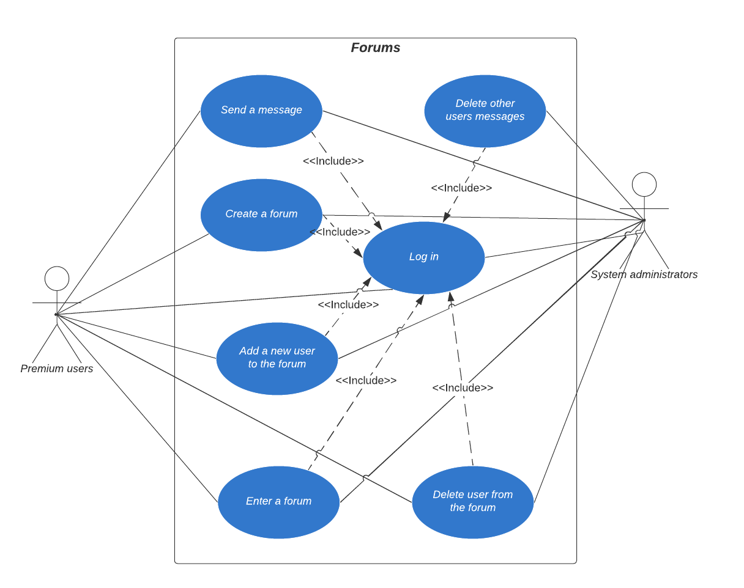
2-5. Figure: Forums use cases
In this section are the functionalities related to the forum. The forum is going to be a Web section in which different users will be able to publish and chat with each other to make the product more interactive. As in the previous sections, the user has to log in before being able to use the functionalities. There are only two actors in this section, the Premium user and the administrator. The Freemium user is not here because it is necessary to be a premium user to use the forum.
Both the administrator and the premium user share the same functionality except for the ability to delete another person's posts, which can only be done by the administrator as their role is to regulate the site rather than participate in it. As it can be seen, the user will be able to create forums or join them. Finally, the user will be able to chat with other users on the forum.
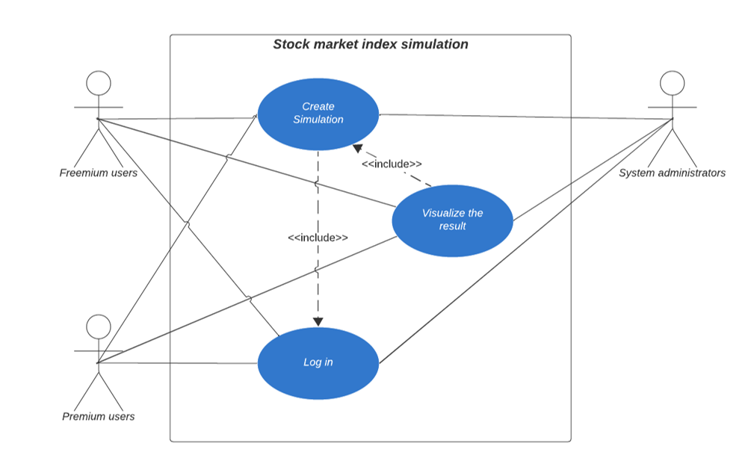
2-6. Figure: Stock market index simualtion use cases
In this section there are the functionalities that correspond to a simulation, i.e. to change an external factor and see how it would affect a future condition. In order to create a simulation, the user must first register in order to know who can create the simulation. Then it has to make the simulation and at the end it will be able to visualize the result of the previously created simulation.

Entity relationship diagram
The entity-relationship diagram of the project's database is composed of 8 distinct entities and 7 relationships between them. All these entities and relationships map the database, define the attributes that each entity or project model has, and how they are related to each other. The database diagram will be explained using the entity-relationship diagram and the entity-relationship model.
An Entity-Relationship Model (ERM) is a conceptual representation of the structure of a database. It includes entities, relationships, attributes, and constraints that define the information to be stored. In an ERM, it is described in more detail how data is captured and how entities relate to each other. Attributes, which are characteristics or properties of entities, are incorporated into the model to provide additional information. The ERM provides a clear and comprehensive view of the database, serving as an intermediate step before designing the database at the physical level. This model facilitates communication between database designers and stakeholders, allowing a deep understanding of the information structure to be managed.
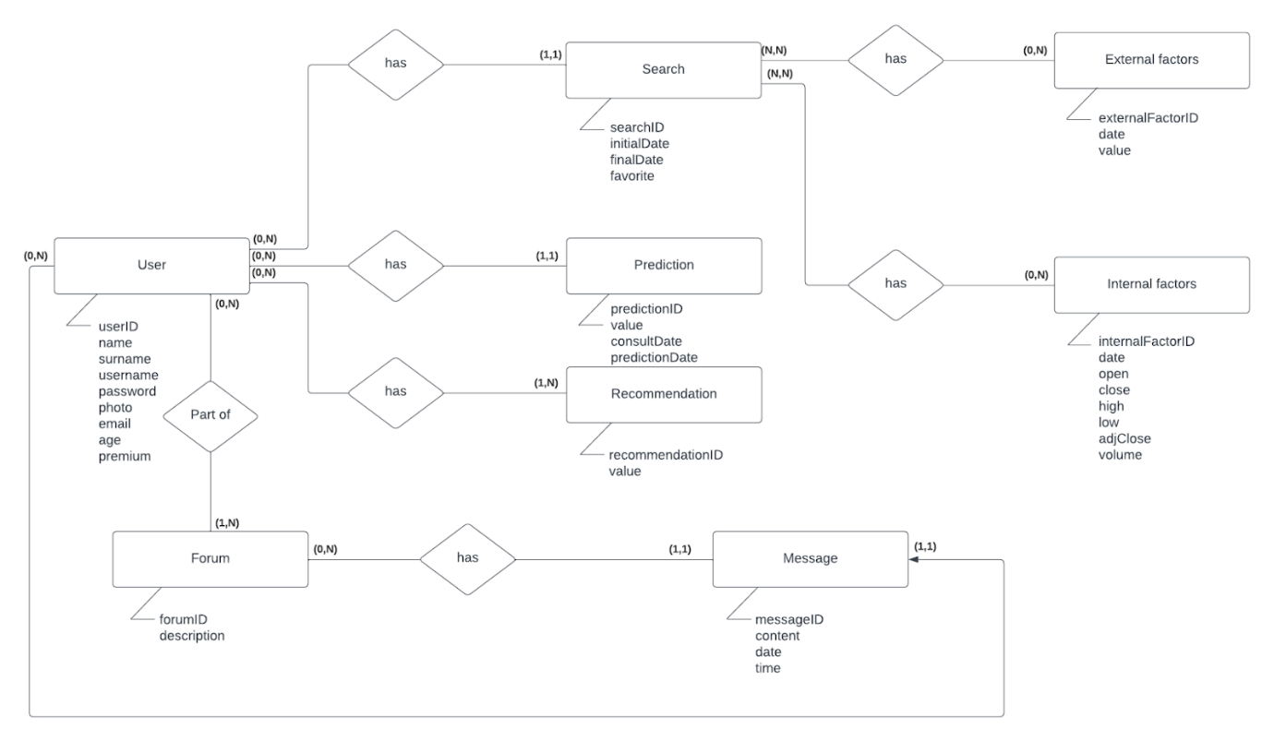
2-7. Figure: Trade Hunter Entity-Relationship Model
An Entity-Relationship Diagram (ERD) is a graphical representation that illustrates entities and the relationships between them in a specific domain. Entities are objects or real-world concepts that have stored data and are clearly distinguishable from each other. On the other hand, relationships establish how these entities are connected or interact with each other. In an ERD, symbols such as rectangles are used for entities, lines for relationships, and diamonds to indicate the cardinality of relationships (e.g., one-to-one, one-to-many). This type of diagram is crucial for visualizing the structure of a database and understanding how different elements relate.
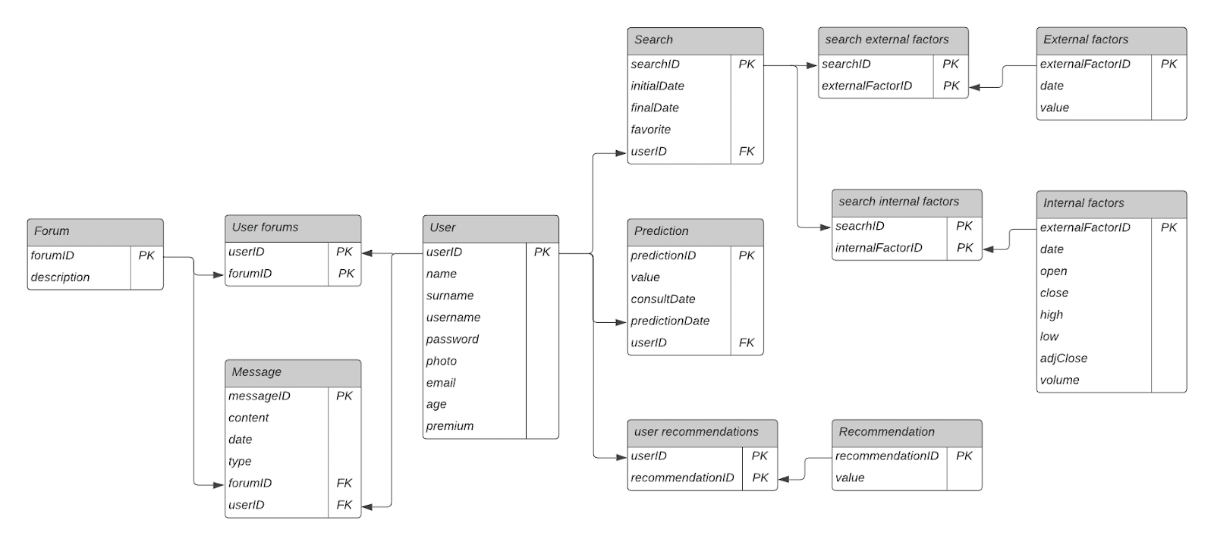
2-8. Figure: Trade Hunter Entity-Relationship Diagram
Looking at the project diagram, it can be seen that the user entity is the most central and important, as it relates to the project's user and is the target of the entire project. This entity has the attributes that the system user has such as username, password, email, etc. The entity is related to entities that represent user functionalities, including Search, Prediction, Recommendation, and Forum. Regarding the Forum entity, it represents the chat functionality that the user has, allowing them to participate in various forums and write messages for information or questions. The Forum entity has attributes id and description only, and it is related to another entity called Messages, where all user messages are archived with attributes id, content, date, and time.
The entities Search, Prediction, and Recommendation represent the three most important functionalities that the user has in the system. The user can make predictions about the stock market index value on specific days and archive them in the Prediction entity, which contains attributes such as value, consultDate, and predictionDate. The Recommendation entity refers to the program's recommendation system, where the client can request advice on where to invest or not. Finally, there is the Search entity, which is related to two entities apart from the User entity: External factors and Internal factors. The user can conduct searches on the index on certain dates and obtain useful information about all the data in that time period and its development. These searches can also be saved as favorites. The other two relationships are due to a search returning two types of data: external factors affecting the index (e.g., euro value, GDP…) and internal factors (previous values, subsequent values, volume…).

Class diagram
A class diagram is a fundamental graphical tool used in the field of software design, specifically in the context of object-oriented programming. This type of diagram provides a detailed and static visual representation of the structure of a system, showing the classes that make up the system. In the case of this class diagram, it has been divided into three parts: controllers, models and configuration files. All parts start from a Main class, but none of them is independent, they are all linked in some way.
To start with, we will talk about the models part. In this part are the model classes, i.e. the base classes of the program. Each of these classes make up the database tables, as well as the relationships between them. The main class would be the User class, which, as can be seen in the relationship entity model (MER), is the central class from which the other classes come. Each of these classes has a service and a repository, which are inside each controller.
The controllers are the classes that receive the user's requests via url and using different methods: GET, PUT, POST and DELETE. They process the necessary information and coordinate the update of the model and the corresponding view. In this project there are several REST controllers (more or less one for each model class) and they make calls to services that in turn call a repository where the CRUD methods are made.
Finally, there are the project configuration classes. For this particular project only one configuration file called WebSocketConfig will be used. This class contains the necessary configuration to be able to use WebSocket in the project, in order to create a connection channel between different users.

Project organization

Project management
To begin with the project organization, regarding the project management that will be done throughout, there are many requirements that must be fulfilled. In this project the Kanban methodology will be used, so, first of all, a document will be done where the initial planning of the project will be presented. In this document the project phases and the life cycle will be defined, where it will be explained how the project development will be done in different phases, along with the product backlog and work items that will be done in each one of them. To ensure the fulfillment of those, the acceptance criteria, level of effort and the prioritization will be specified, as well as the roles of each one of the team members and the explicit policies rules such as definition of done and criteria. In addition, all this will be presented with a Gantt chart, to see visually the project’s development process.
Once the initial planning is done, through the entire process the Kanban methodology will be implemented by doing regular meetings and filling the corresponding documentation. All this will be used for the monitoring of the project, as well as to ensure the correct progress of the project throughout the project. Apart from writing the documentation, the kanban artifacts such as the kanban board and charts will be used to represent all the progress done. To do this, a free program that is not Excel will be used, so that the artifacts will be created automatically while the progress is updated instead of doing it manually.

Web engineering II
As for the web engineering part of this project, three fundamental objectives are defined that determine its approach and functionality. Firstly, it aims to establish a solid infrastructure for the exchange of data between systems through the efficient use of XML and JSON formats. To achieve this, Java objects are used to collect and generate data in XML or JSON formats using the parsing and processing technique known as Object-Document parsing. In addition, schemas are implemented to validate documents, ensuring the integrity and coherence of the information that will be communicated between systems.
Secondly, emphasis is placed on the implementation of web services as essential bases for effective communication between the various components of the system. These services are not limited merely to query operations (GET Method), but also cover the ability to make modifications to the server through methods such as PUT, POST and DELETE. This operational flexibility extends the functional scope of the system, allowing not only the retrieval of data, but also its manipulation and updating in an efficient and secure manner. In addition, an approach based on service-oriented APIs is adopted, used for most of the functions, including database access, method invocation, and the use of artificial intelligence functionalities. Communication between systems is effectively achieved through these services, providing a robust and modular architecture.
Finally, the use of a system integration framework, in this case, Node-RED, is proposed as the third base of the web engineering strategy. This framework not only facilitates the basic connection between systems, but also incorporates advanced functionalities of an Enterprise Service Bus (ESB). From registration and discovery to orchestration and proxy translation, Node-RED provides a versatile platform for efficient integration and service management.
Together, these three objectives are the main base of the web project strategy. They help to organize and share data, implement web services and make different systems work well together, thanks to a special tool called Node-RED.

Operating systems
The objective regarding the operating systems of the project is to address synchronization problems through diverse techniques. To achieve this, a stock market index simulation will be done in the project, where there will be many threads that will simulate real factors such as euro value or inflation rate. The problem of synchronization of these threads will be solved by different techniques (barriers, queueing, signaling…). In addition, this involves documenting the multithreading design comprehensively. Furthermore, it necessitates documenting encountered synchronization issues and the corresponding techniques used, along with implementing a functional solution.
Additionally, the project requires an elevation in synchronization complexity as well as optimizing application efficiency. This includes expanding the variety of thread types and their interactions within the system. An efficient use of computer resources is crucial, ensuring the avoidance of resource-intensive practices like busy-waiting or polling. Moreover, the project extends its synchronization requirements to include solving additional problems through message passing. This involves using message passing as a technique to address synchronization challenges, improving the predictive capabilities of the stock market index simulation.

Professional software development
In the professional software development area, the objective is to deliver high-quality software, a structured approach to project development takes center stage, evolving through distinct phases that contribute to the continuous improvement of the software's reliability, maintainability, and efficiency.
Looking forward, at the very initial testing process the objective will be just to obtain a basic structure for the program testing and quality. Testing efforts are expected to transition from rudimentary to sophisticated, resulting in a low test coverage and basic structured test cases. Anticipated improvements include a low test case quality, with the integration of mocks becoming standard practice for effective unit testing. Additionally, the use of code quality analysis tools like SonarQube and SonarLint, alongside automated integration processes, won't be necessary for this initial phase.
Advancing into the medium phase, will be a concerted effort to elevate software quality. Test coverage is expected to continue expanding, and test cases will be optimized for issue identification and resolution. Continuous improvement of test case quality, accompanied by use of mocks for reliable unit testing, will be prioritized. Integration tools for code quality analysis, such as SonarQube and SonarLint, will be used in order to ensure the high quality of the software. Continuous integration tools like Jenkins or GitLab will persist in automating tests after each merge, following a refined branching strategy. Code metrics, encompassing Cyclomatic Complexity, Code Smells, Bugs, and Vulnerabilities, are expected to consistently sort out and obtain acceptable levels.
Looking ahead to the final phase, the focus will intensify on achieving optimal code quality and test coverage. Comprehensive testing practices will ensure software reliability, and test cases will be optimized for seamless issue resolution. High-quality test cases and an extensive use of mocks in unit testing are going to be used. Continuous code refactoring will be an ongoing process, further enhancing maintainability and readability.

Artificial intelligence
Regarding the artificial intelligence part of the project the planification will be divided into 4 different parts or evaluations: Agent design, agent development, final decision making test and agent deployment. In the initial stages, a rudimentary AI will be crafted, serving basic functions such as search operations or learning from provided examples. Progressing further, an advanced AI will be designed, this advanced agent will engage with tabular data, handling tasks like optimization and recommendations, employing sophisticated techniques such as neural networks. Finally , the objective will be achieved by developing an advanced AI that effectively utilizes real-world data, encompassing time series, images, and text, deploying cutting-edge methodologies such as deep learning and reinforcement learning.
Starting the AI development process involves basic work, including basic data preparation, model creation, and ensuring overall coherence. As the development advances, a comprehensive approach is adopted, encompassing all necessary steps for constructing an intelligent AI. That involves the application of advanced systems, including fine-tuning parameters (hyperparameters), implementing intricate data preprocessing techniques, and utilizing sophisticated model selection strategies. In the final stages, state-of-the-art methodologies will be employed across data preprocessing, model construction, and validation.
The evaluation phase requires examining the AI's performance. Initially, the focus will be on functional efficiency. Progressing further, the assessment includes not only effective operation but also guards against overfitting—ensuring the AI does not over-adapt its responses. Finally, the AI has to demonstrate exceptional functionality, operating seamlessly without succumbing to overfitting concerns.
Transitioning from development to deployment, the initial deployment will involve non-real-time decision-making by the AI. In the subsequent phase, the AI will be deployed to autonomously operate, relying on file-based interactions. The final deployment phase will transform the AI into a web service, ready to perform intelligent operations whenever required.

Development environment
The development environment for this project will include several key components. Firstly, it will include JavaDoc/Doxygen documentation specifically focusing on the most complex and critical functions within the codebase. This means that the code will be filled with comments that will help to understand it, and these comments will be used to automatically create the corresponding documentation. This will serve as a comprehensive reference, elucidating the intricacies of these crucial functions.
Secondly, a codification standard will be established and adhered to throughout the project. This standard will set guidelines and best practices for coding, ensuring uniformity, readability, and maintainability across the codebase. It defines practices such as indentation, line length, variable naming conventions, commenting, and file organization, aiming to ensure code readability, maintainability, and uniformity across the project, regardless of the number of contributors. Following this standard will help to improve the results of the measures of Software Development, as well as to do a better organized code.
Thirdly, the project will use a shared version control repository, most likely Git, to manage and track changes made to the codebase. This repository will facilitate collaboration among team members, allowing for versioning, branching, and merging of code changes seamlessly. The version control system that will be used is GitHub, as the repository must be private and be shared between 6 people, being GitHub the only one that gives the chance to do it for free.
Lastly, critical functionality automatic tests will be implemented within the development environment. These tests will be able to ensure the correct functioning of the Web server functions. They will run automatically to ensure that critical aspects of the system are functioning as expected, providing an added layer of assurance and reliability to the project. The tool that will be used for doing the tests automatically will be Jenkins, so that the result of all the processes can be monitored.

